1. Creating and Renaming Files/Directories
Create a directory named test_dir using mkdir :
- command : mkdir test_dir
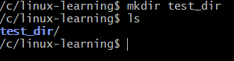
Inside test_dir, create an empty file called example.txt.
- Commands : cd test_dir -> touch example.txt
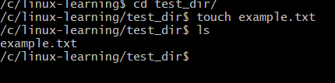
Rename example.txt to renamed_example.txt using mv
- Commands : mv example.txt renamed_example.txt
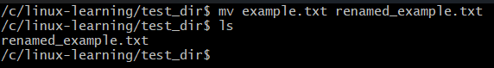
2. Viewing File Contents
(I am using my work system hence I created a file password.txt)
Use cat to display the contents of /etc/passwd.
- Commands : cat pasword.txt
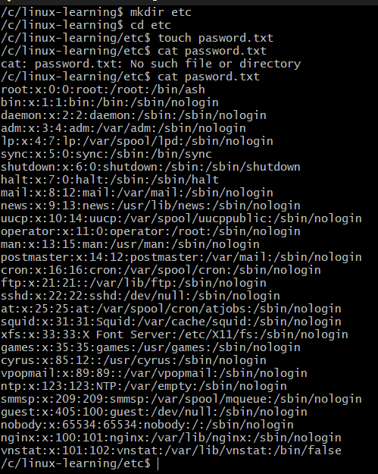
Display only the first 5 lines of /etc/passwd using head.
- Commands - head -5 pasword.txt
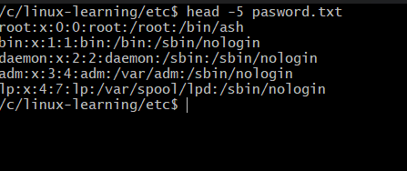
Display only the last 5 lines of /etc/passwd using tail.
- Commands : tail -n 5 password.txt
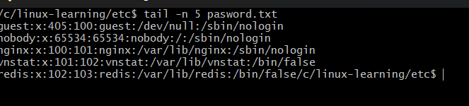
3.Searching for Patterns
Use grep to find all lines containing the word "root" in /etc/passwd.
- Command : cat pasword.txt | grep "root"
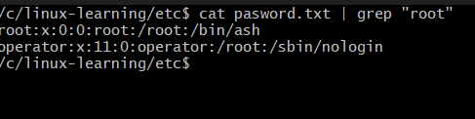
4. Zipping and Unzipping
(Unable to attach screenshots as im using work device with windows- zip is not being recognized and im not admin user)
Compress the test_dir directory into a file named test_dir.zip using zip.
- Command : zip -r test_dir.zip test_dir
Unzip test_dir.zip into a new directory named unzipped_dir.
- Command : unzip test_dir.zip -d unzipped_dir
5. Downloading Files
(wget is not recognized hence i used curl)
Use wget to download a file from a URL (e.g., https://example.com/sample.txt).
- Commands : wget https://example.com/sample.txt
- Command used : curl https://example.com/sample.txt
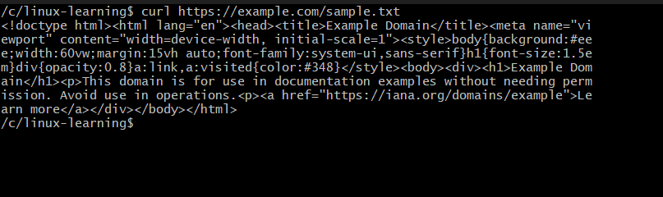

6. Changing Permissions
Create a file named secure.txt and change its permissions to read-only for everyone using chmod.
- Commands : touch secure.txt -> chmod 444 secure.txt
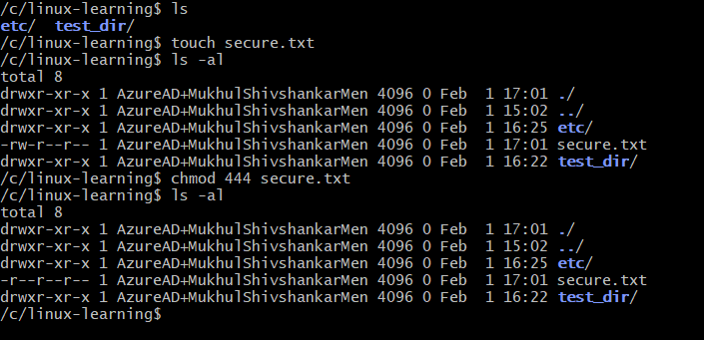
7. Working with Environment Variables
Use export to set a new environment variable called MY_VAR with the value "Hello, Linux!".
- export MY_VAR=“Hello, Linux!”
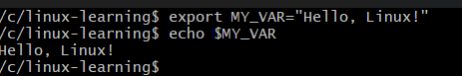

Submission Guidelines -: Attach Screenshots or command along with explanation and submit in doc(google doc or microsoft doc) format also attach github repo link

